Question 1- Jarrod manages a muffin and scone shop. He surveyed locals on whether they preferred muffins or scones. The results are summarised in the table below.
Interpreting Tables Worksheet
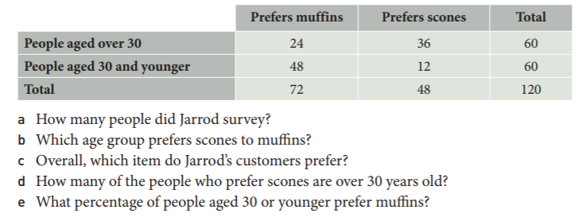
Question 2: This table shows the smoking habits of the adult population of Cengage Beach
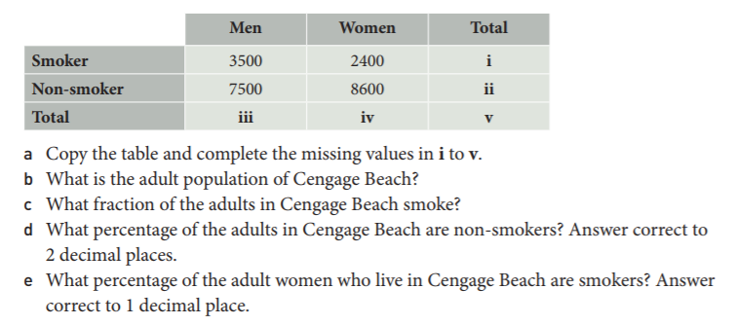

Question 3- Simon runs a café. He recorded data about who buys hamburgers and chicken burgers
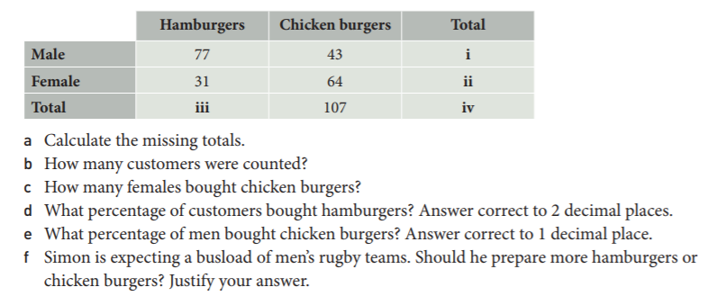

Question 4- Peta found this table in an advertisement for the local gym. The data was obtained by surveying people at random form the local area
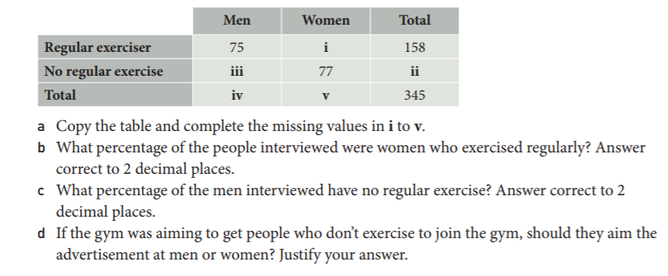

Question 5- Alannah surveyed a group of people for their opinion on changing the Australian flag. This table shows the results.
